How would you define volume?

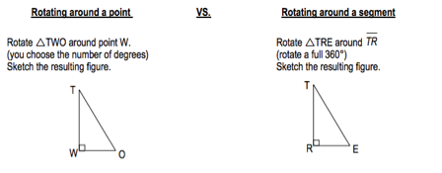

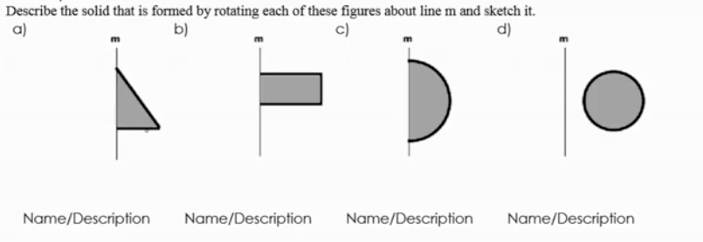
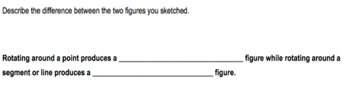
Challenge: Rotate each of these figures around line M. Name and/or describe the figure that is formed

How did your results compare to your groups? Did you have any misconceptions?

Applied
- Sketch the figure formed after a 360 degree rotation around AN
b. Is NT =6 and AT = 10. Determine the area of the base of the 3-D figure
c. Determine the height of the 3-D figure
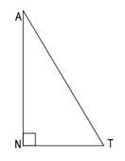

2. Given DU is congruent to UG, sketch and describe the figure formed by a rotation around DU
b. If DU = 18, determine the circumference/perimeter of the base in terms of π
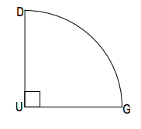

Intro to volume
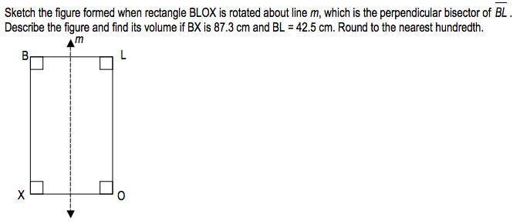

Homework: Ed-puzzle 5 minute video

1. What is a cross section?

Q 2-4:
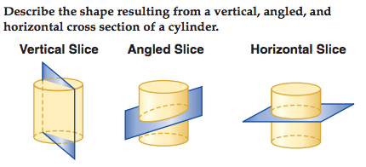

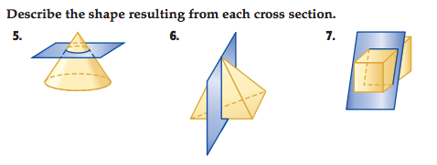
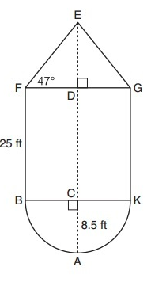
8. What 3 shapes are formed if the figure below is rotated 360 degrees around segment AE

