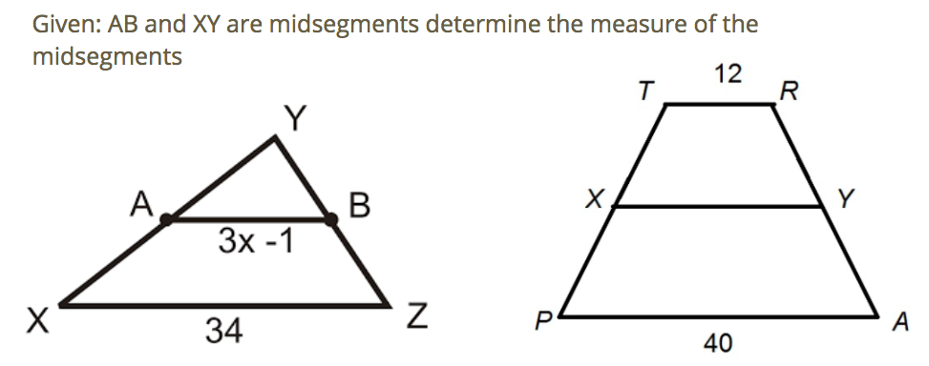

**Rhombus**

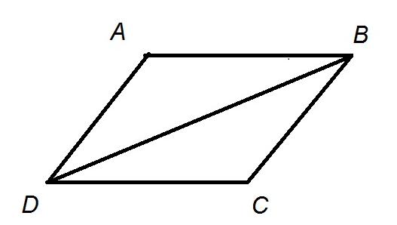Given: ABCD is a rhombus

1.What type of triangles are both ABD and CDB?

2. Are they congruent? If so, by which rule?

3. Which angles are congruent?

4. What do we notice when a second diagonal is added?

**Applying the properties of a rhombus**

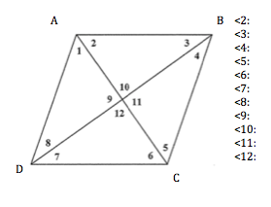

Given: ABCD is a rhombus whose diagonals intersect at point E.

<1 = 40

AC = 24

BD = 32

1. Determine the measure of all angles.
2. Determine the measure of the perimeter

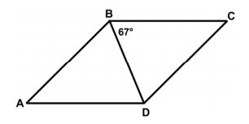**Determining angles and segments (bronze)**

Given ABCD is a rhombus, answer the following

1. Which segments are congruent?
2. What type of triangles are BCD and DAB?

1. Determine the measure of each of the following

1. m<BDA: (*alternate to <DBC) 2. m<CDB: (base angles of an __________ triangle)*

3. m<DBA: (alternate to <CDB) 3. M<BAD: (triangles sum to 180)

4. m<BCD: (opposite angles in a parallelogram)

**Bronze:**

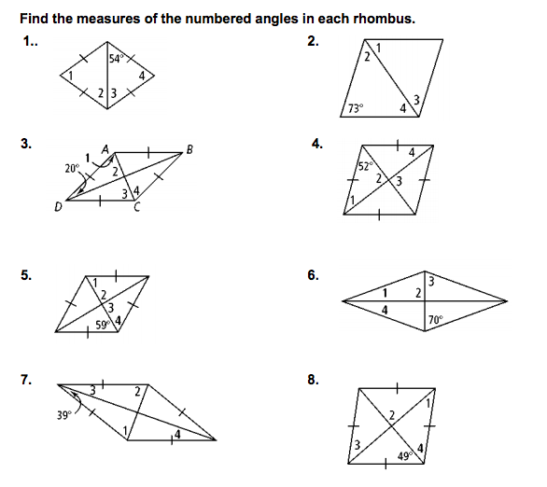

**Silver:**

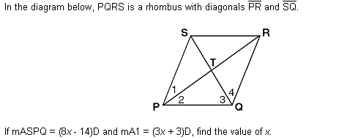1] In the diagram below, PQRS is a rhombus with diagonals and.

If ∠SPQ= 8x – 14 and m∠1= 3x + 3, then find ∠SPQ.

*(Hint: What relationship do angles 1 and 2 share?)*

2) The diagonals of a rhombus have lengths of 12 centimeters and 16 centimeters. Find its perimeter.

3) In rhombus PINK, PI = 3x +7 and IN = x +19, what is the value of NK?

(Hint: draw a diagram)

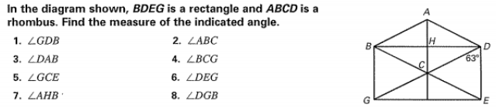4)

Gold

