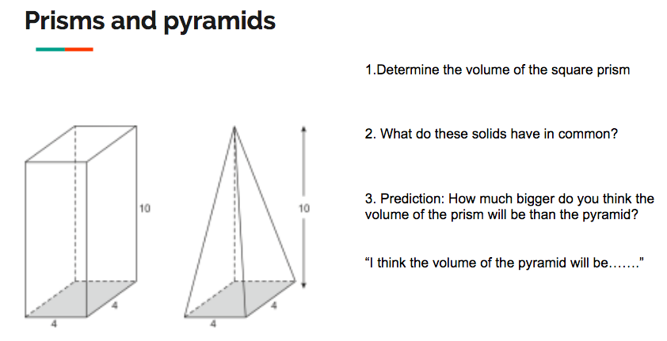

4. How is a pyramid with the same base and height related to a prism?

5.What is the equation for volume of a pyramid?

6. Determine the volume of the Square pyramid:

7. How is a pyramid constructed?

Prism or pyramid (bronze)
For the following, Identify if it a prism or pyramid, then solve for the volume.
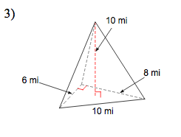
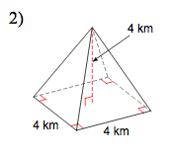
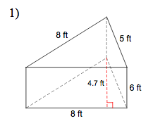

Solid type:

Solid equation:

Base shape:

Area of base:

Height of solid:

Volume:

Solid type:

Solid equation:

Base shape:

Area of base:

Height of solid:

Volume:

Solid type:

Solid equation:

Base shape:

Area of base:

Height of solid:

Volume:

Silver:
Determine the volume of the square pyramids (be careful with what numbers you use)
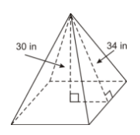
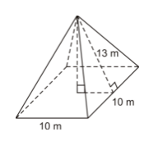

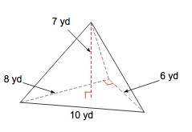
Sketch and solve
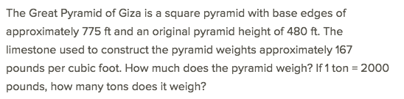

Gold
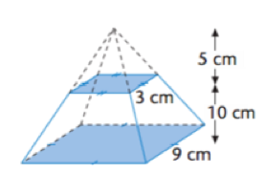
1a. Determine the volume between the two shaded levels

b. If the item is made of brass and weighs 8.4g per cm³, what is the total weight between the shaded levels?

Q2,3,4: Manipulate the equation of a pyramid to solve for the following

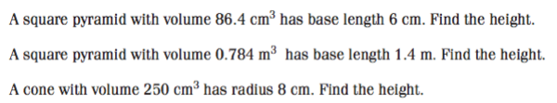
Exit ticket
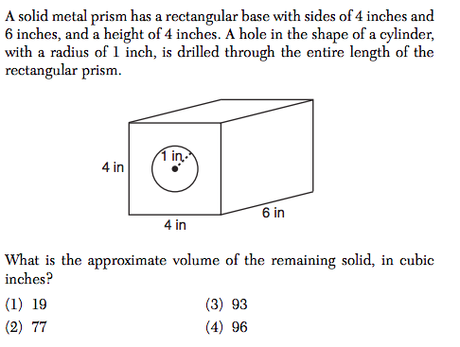
Show your work or explain your reasoning:

Don’t forget to annotate the question

Exit ticket

Show your work or explain your reasoning:

Don’t forget to annotate the question

