Given: Rectangle UXWV and m<XUS =36  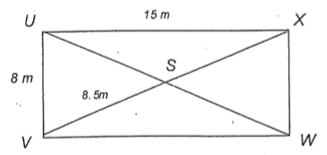  Determine the measure of the following:  1. XW: 2. VW:  3. XS: 4. WS:  5. US: 6. <VUS  7. <UVS 8. <USV  9. <USX 10. <UXS  11. Which triangle/s are congruent to:  a. VSW  b. USV |  | Given: Square ABCD  Determine the measure of the following:  - CE:  - BE:  - DE:  - AB:  - m<ACD:  - m<AEB:  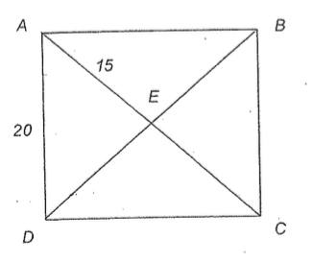  - Which triangles are congruent to DEC?  - Which triangles are congruent to ADC?
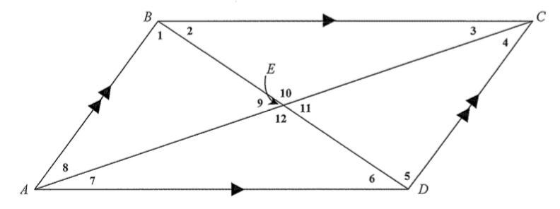
Given: Parallelogram ABCD,

BE: 6, AC: 18, AB: 8, BC: 15

<1: 65, <2: 50, <3: 40

Determine the measure of the following:
- <4  - <5  - <6  - <7  - <8  - <9  - <10 | - <11  - <12  - ED:  - BD:  - AD:  - AE:  - CD: |  | Which rigid motion would map AED onto CEB?

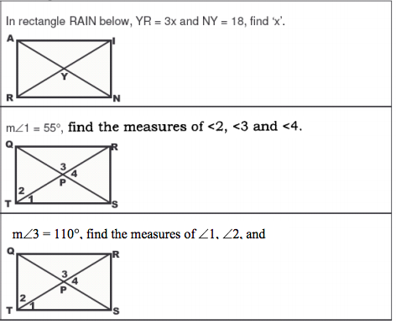
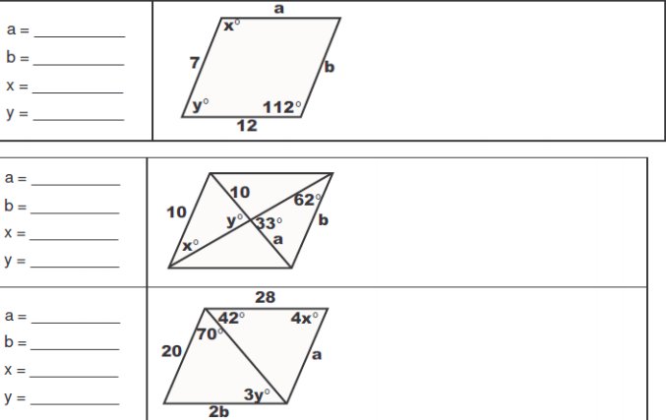

ABCD is a parallelogram, solve for
a. <CDB: b. < C:
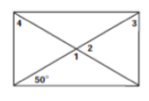
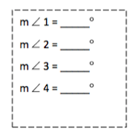
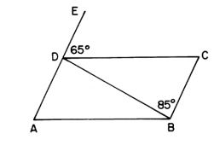

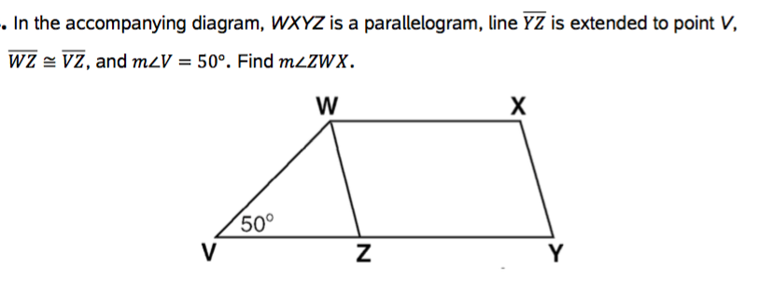
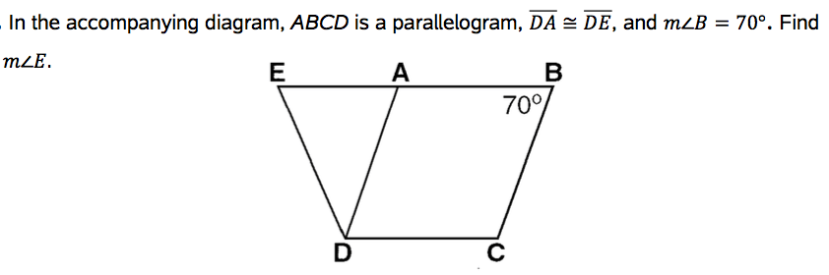

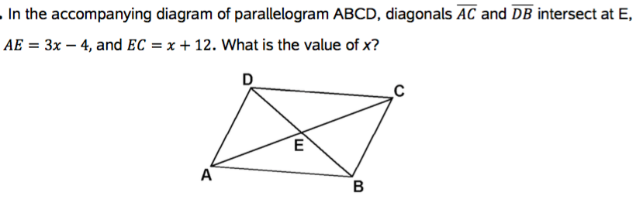
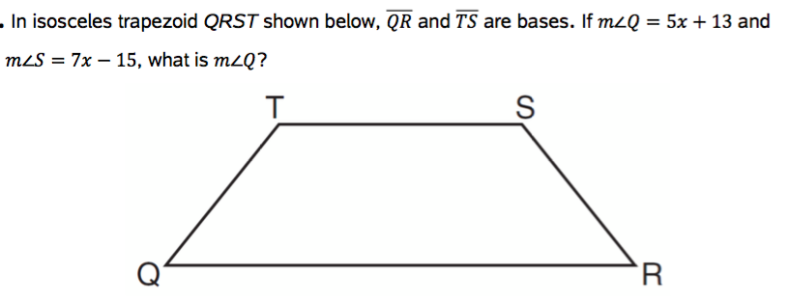

Extension
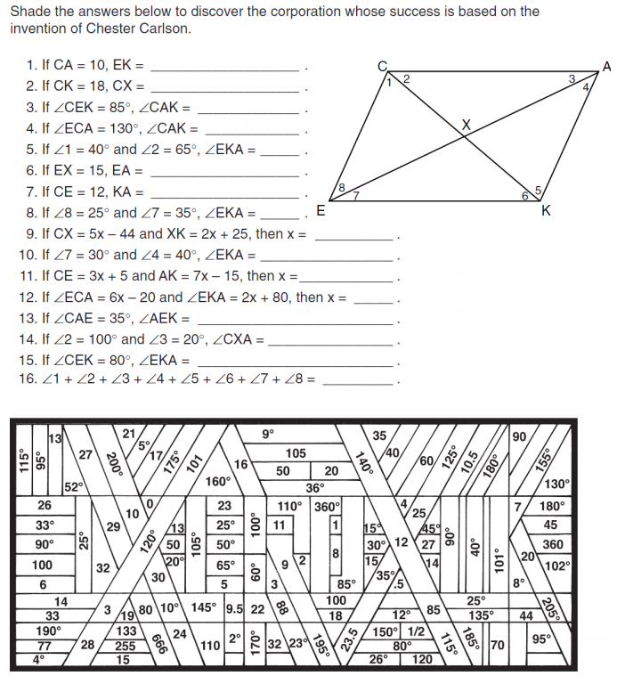
Problem: Prove that quadrilateral METS is a square given the vertices
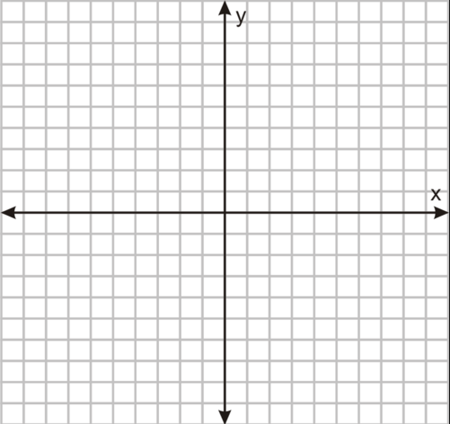
M ( -2, 2 ), E (4, 2 ), T ( 4, 8 ) and S (-2, 8 )

Side name | Slope | Length
Conclusion:

