Properties of a parallelogram and rectangle

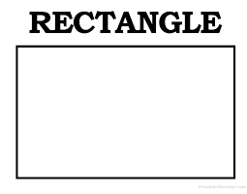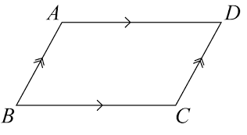

**So how can we apply the properties to proofs?**

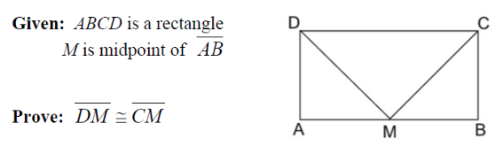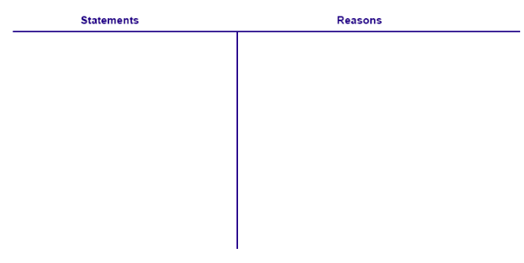

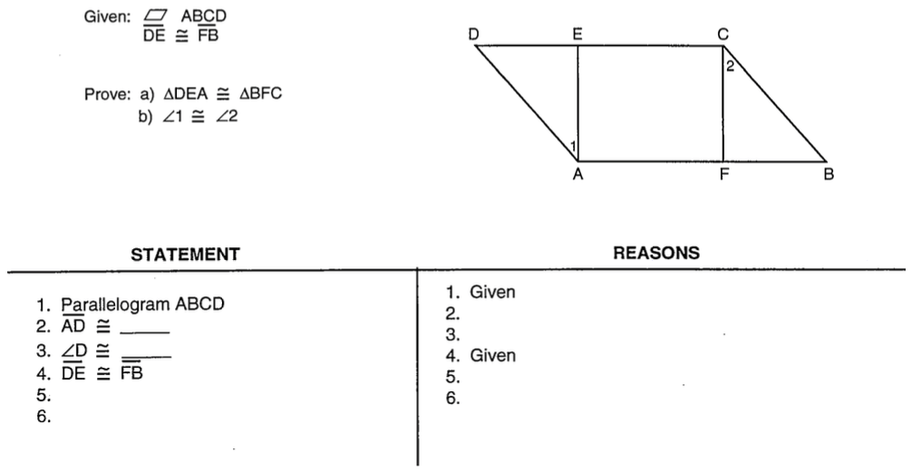

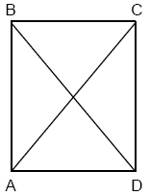Application

1. In the accompanying diagram of rectangle $ABCD$, $m∠BAC=3x+4$ and $m∠ACD=x+28$. What is $m∠CAD$?   
   1. 12
   2. 37
   3. 40
   4. 50
2. In rectangle *ABCD*, *AC* = 3*x*+15 and *BD* = 4*x*–5. Find the length of $\overline{AC}$. (Draw a picture)

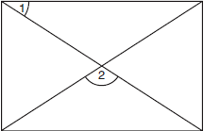

1. As shown in the accompanying diagram, a rectangular gate has two diagonal supports. If $m∠1=42$, what is $m∠2$?

4a) In the accompanying diagram of rectangle *ABCD, $m<BAC=3x+4$* and

$m<ACD=x+28$

*Determine the measure of <CAD*

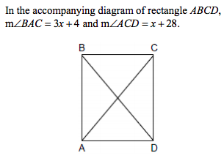

b. Using your answer from A and given AD is 10. Determine the measure of CD to 1 decimal place

5. Use the properties of parallelograms to solve for the unknown angles

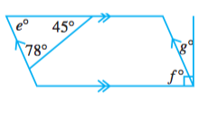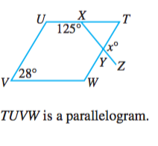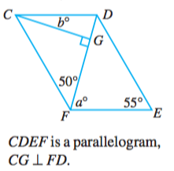

Regents ready

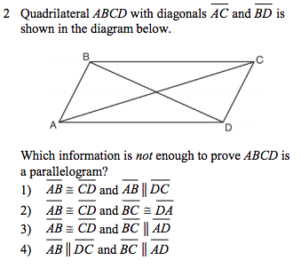

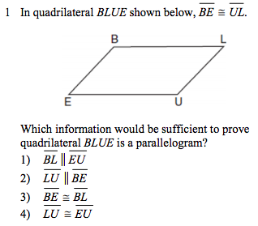

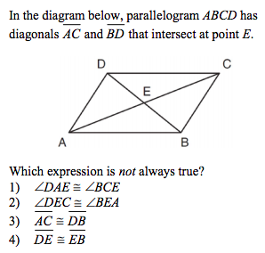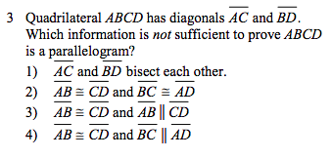

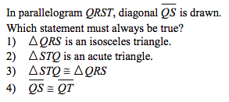

‘

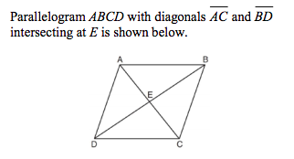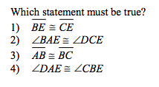

Exit ticket



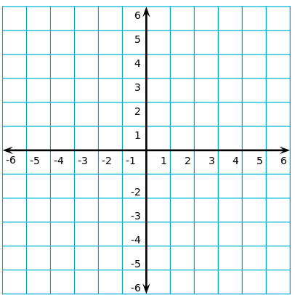

Exit ticket



