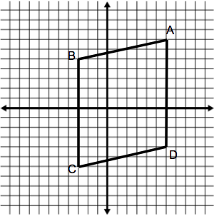
Do Now: In the following quadrilaterals, given that AB//CD and AD//BC, make as many conclusions as you can about ABCD
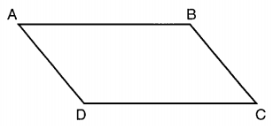
Think about angles and side lengths.

Properties of Parallelograms:

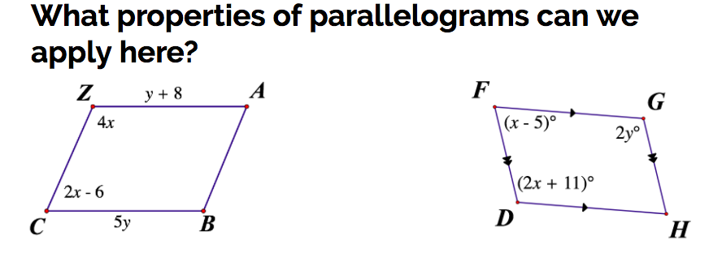
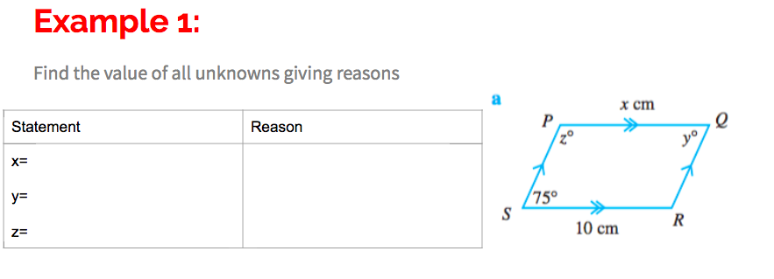
Solve for both x and y in both parallelograms.

Given WVYX is a parallelogram. Determine the value of x.
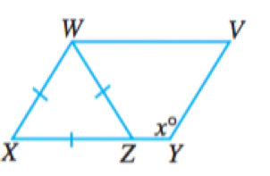

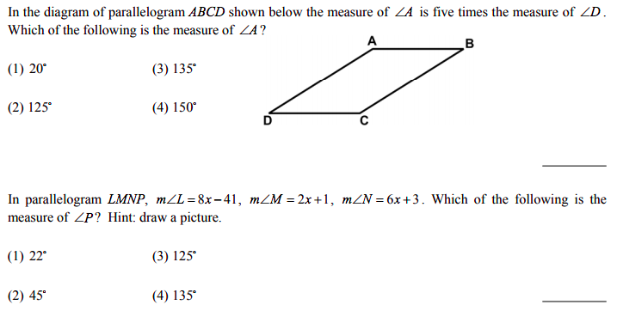

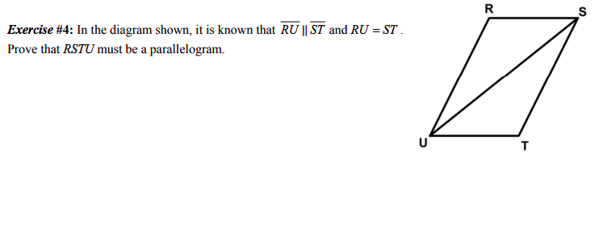
What do we need to prove before showing its a parallelogram?

