Practice:

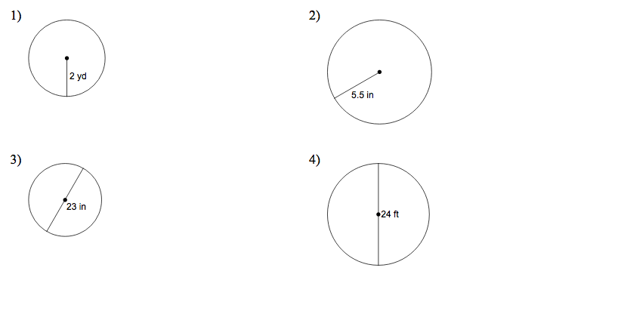Find the **area** and **circumference** of each circle. Leave your answers in terms of π and to one decimal place.

Area:

Circumference

Area:

Circumference

Area:

Circumference

Area:

Circumference

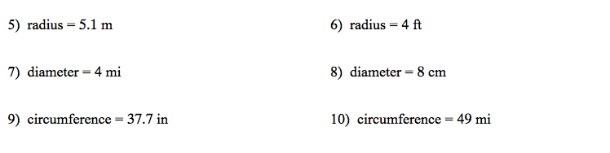Determine the **area** of each circle:

**Sectors**

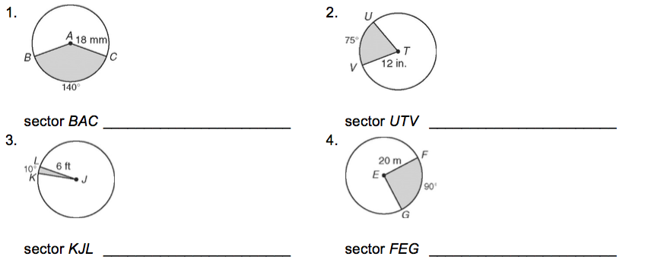Determine the area and arc length of the following sectors

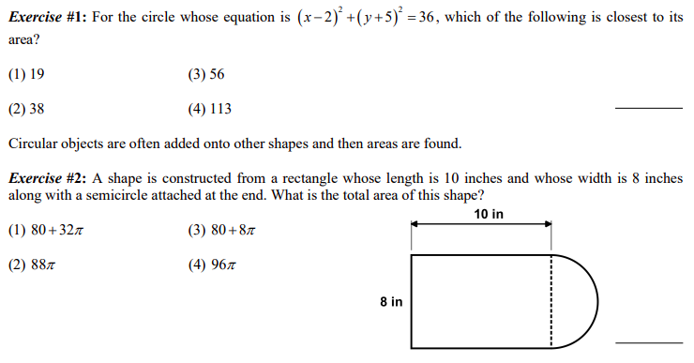Application: Problems involving circles and half circles

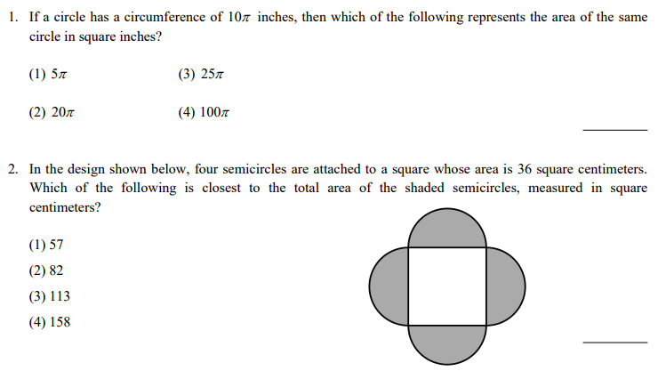

Problems involving sectors

