Spicy
1. A Patio is to be built in the shape of the given isosceles triangle.
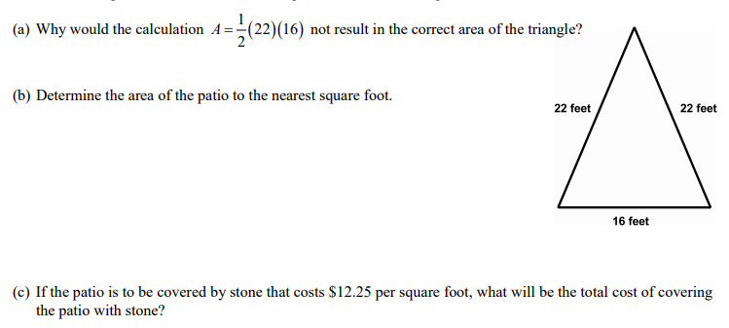
2. Parallelogram ABCD has coordinates of A(0,6), B(9,6) and C (6, -2)

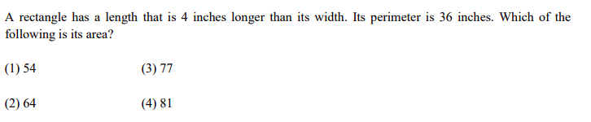
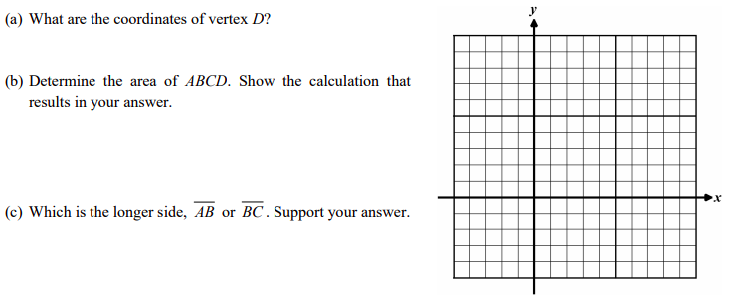
3.
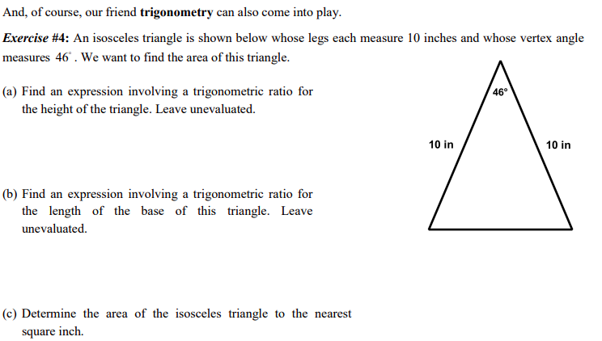

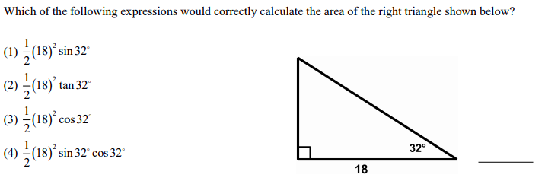

5.
6.
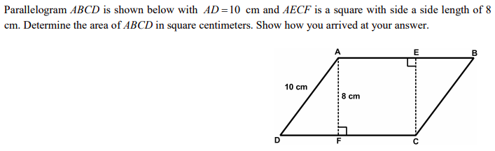

Practice: Determine the area of the following triangles A = ½ bh
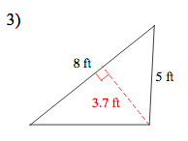
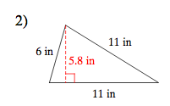
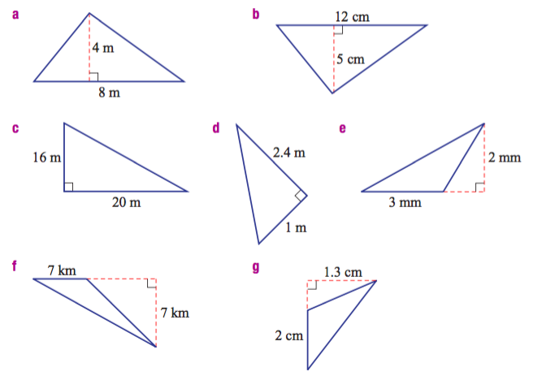
Identifying the perpendicular height/altitude and base then solve for area
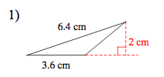

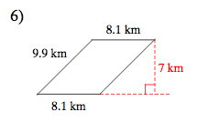
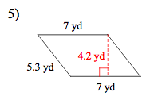
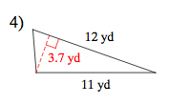

Harder skills problems
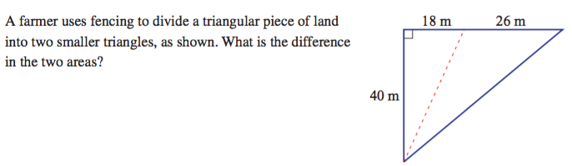

Hint: Draw in the perpendicular height by splitting the triangle in half

