Congruence Review Sheet

1) Draw an example of each of the following congruence rules.

SAS AAS SSS ASA HL

2) Explain why AAA is not a congruence rule. What can we use AAA for?

3)
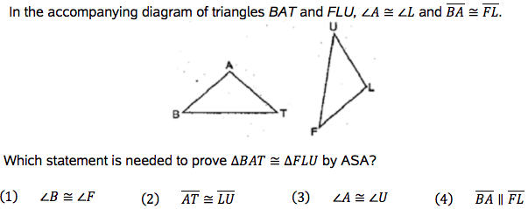

4) Given that triangle ABC is congruent to triangle XYZ, identify the 3 pairs of corresponding sides and the corresponding angles. Draw a diagram to help you.

Sides: Angles:

5) 6)
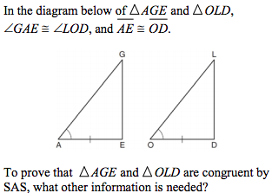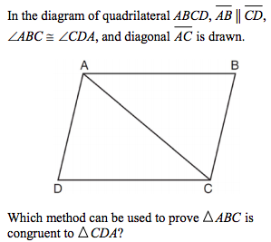
7)
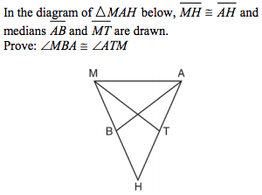
Statements | Reasons
8)
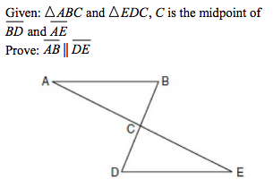
Statements | Reasons

