**Math Stretch: write your description of the series of rigid motions**

**(Slide 2) Angle estimates:**

**Answer the first 2 questions while completing the activity on Mesa Math**

**1. What is a central angle? (What parts of a circle does it touch or include)**

**2. What is the relationship between a central angle and it’s arc?**

**Activity 1:**

X

**Using the letters shown in the diagram, name:**

1. Four central angles: ______ ______ ______ ______

W

2. Two semicircles: ______ ______

Q

3. Four minor arcs: ______ ______ ______ ______

Y

4. Four major arcs: ______ ______ ______ ______

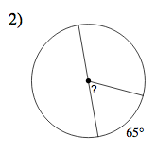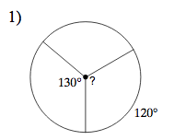

Z

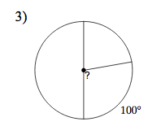

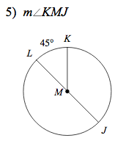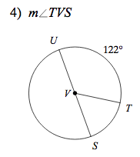

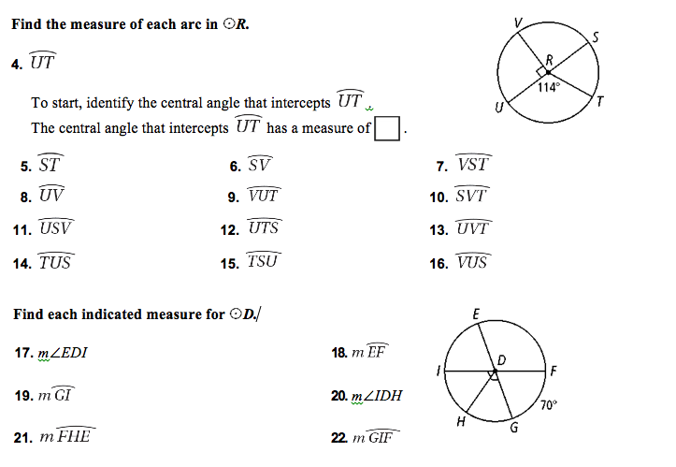

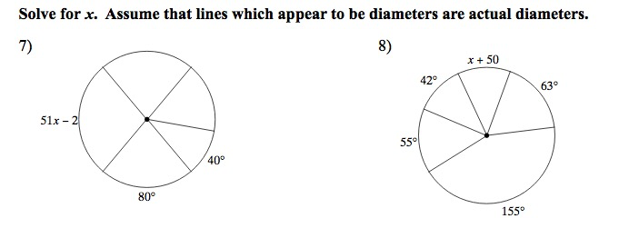Challenge

In the following diagram, solve for as many Arcs and angles as you can.

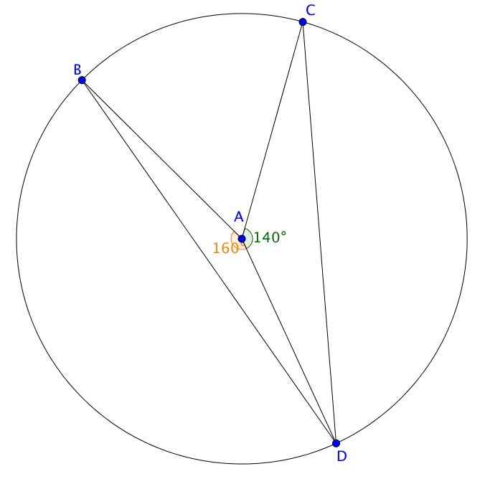Given: BA, CA and AD are Radii

What do you notice about m<BDC compared to the m<BAC? Or ARC BC?