- Determine the value of the pronumeral and provide a brief reason for your answer
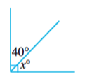
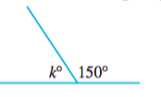
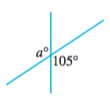
a) B) c)

- Determine the value of the variable.
- Give a reason for how you set up your equation.

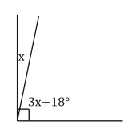

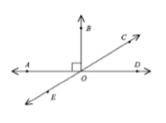
- If <BOC is 72 degrees find the following giving reasons
Statement | Reason
<COD =
<AOE =

< ________ and < __________  are adjacent angles | I know this because
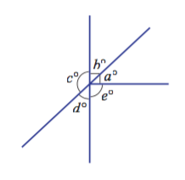
5. Given angle D = 55. Determine the value of each other angle. (BE SPECIFIC)

m<C = 125
Reason: supplementary to <D (straight lines =180)

6. Determine the value of the variables and use it to determine the measure of each angle
