HW Due 3/26 - EdPuzzle Name: ______________

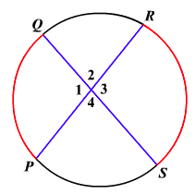
Chords QS and RP intersect (not at the center), forming four angles in the center.

Relationship between angles:

Angles of Intersecting Chords Theorem: When chords intersect

in a circle, then the measure of the angle is _________________

___________________________________________________________.

Our Example:

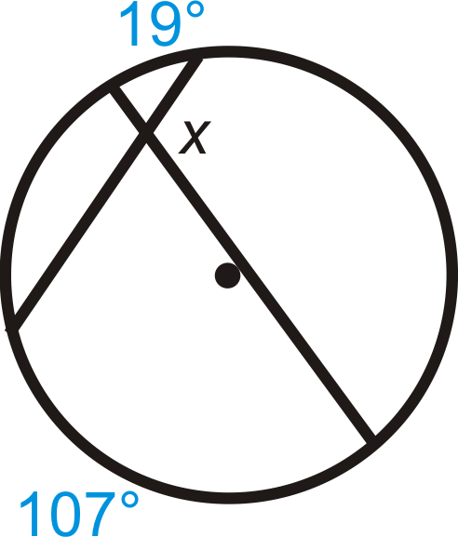
HW Due 3/26 - EdPuzzle Name: ______________

Chords QS and RP intersect (not at the center), forming four angles in the center.

Relationship between angles:

Angles of Intersecting Chords Theorem: When chords intersect

in a circle, then the measure of the angle is _________________

___________________________________________________________.

Our Example:

