**Section 2.1 – Rates of Change and the Derivative Worksheet #1 Solutions**

Solve.

1. **Average Rate of Change.** A rock falls from the top of a tall cliff. Experiments have shown that dense, solid objects dropped from rest to fall freely near the surface of the earth will fall 16*t*2 feet in the first *t* seconds. What is the average speed during the first 2 seconds of fall?

 ft/sec

2. **Instantaneous Rate of Change.** Find the instantaneous speed of the rock at the instant *t* = 2 seconds. To do so, calculate the average speed of the rock over the interval from *t* = 2 to a slightly later time.

Complete the following table.

|  |  |  |  |  |
| --- | --- | --- | --- | --- |
| Time Interval | Start *t0* | End *t* | ∆*t* |  |
| [2, 2.1] | 2 | 2.1 | 0.1 |  |
| [2, 2.01] | 2 | 2.01 | 0.01 |  |
| [2, 2.001] | 2 | 2.001 | 0.001 |  |
| [2, 2.0001] | 2 | 2.0001 | 0.0001 |  |

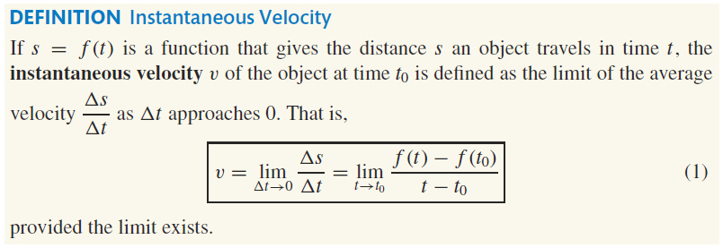

3. Use the definition of instantaneous velocity to find the instantaneous velocity of the rock at

*t* = 2 seconds.



**Section 2.1 – Rates of Change and the Derivative Worksheet #2 Solutions**

In Problems 1 and 2, find an equation for the tangent line to the graph of each function at the indicated point.

1. *f*(*x*) = *x*2 + 4 at (–1, 5) 2.  at (4, 2)

 



Tangent Line: *y* = –2(*x* + 1) + 5

*y* = –2*x* + 3

Tangent Line: *y* = ¼ (*x –* 4) + 2

*y* = ¼*x* + 1

In Problems 3 and 4, find the derivative of each function at the given number.

3. *f*(*x*) = 3*x* – 1 at –1 4.  at –2

 



**Section 2.2 – The Derivative as a Function Worksheet #1 Solutions**

Differentiate each function. Graph *y* = *f*(*x*) and  on the coordinate planes provided.

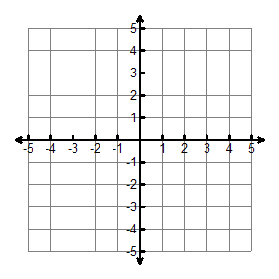

*y* = *f*(*x*)



1. *f*(*x*) = 3*x* + 2





2. *f*(*x*) = *x*2 – 3



*y* = *f*(*x*)





**Section 2.2 – The Derivative as a Function Worksheet #2 Solutions**

Differentiate each function. Graph *y* = *f*(*x*) and *y* = *f’*(*x*) on the coordinate planes provided.



*y* = *f*(*x*)

*y* = *f’*(*x*)

1. *f*(*x*) = *x*3





2. *f*(*x*) = 



*y* = *f*(*x*)

*y* = *f’*(*x*)



